
Guide to the HMC Projects Online Application

We are delighted that you are applying for a HMC Scholarship. Each candidate applies through a scholarship competition in his or her own country, organised by a HMC Country Coordinator. This document sets out information to help guide you through the online application for HMC Projects Central & Eastern Europe.
The application process begins on this link:

HMCP ONLINE APPLICATION PLATFORM
https://hmcprojects.schooladminonline.com/portal

Before applying for the scholarship, all candidates have the obligation to pay administration fee in the amount of 75 KM. This fee is non-refundable. Payment instructions are here:
Bank account for Udruzenje PLUS
ASA Banka – account number 1340011130003225,
Please add the reference comment
„Uplata administrativne takse za HMC stipendiju”.

We would ask that the first six sections of this application (finishing with Personal Essay) are completed by you (the student), whilst the last two are completed alongside your parents.
You can at any point 'Save & Finish Later', so it is not necessary to complete the application at one time. You can only submit your application once.
Section 1: Country Questions
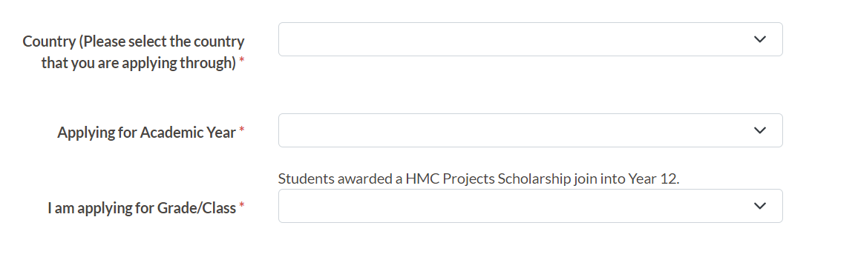
You will then get a question about the type of scholarship you are applying for e.g. Full Scholarship, Reduced Fee Scholarship
Country Coordinator Comment: U različitim obrazovnim sistemima razredi se različito zovu. Pisat će da se prijavljujete za year 12. Nemojte da vas to zbuni – bitno je da po godinama starosti ispunjavate kriterij.
Section 2: Applicant Information
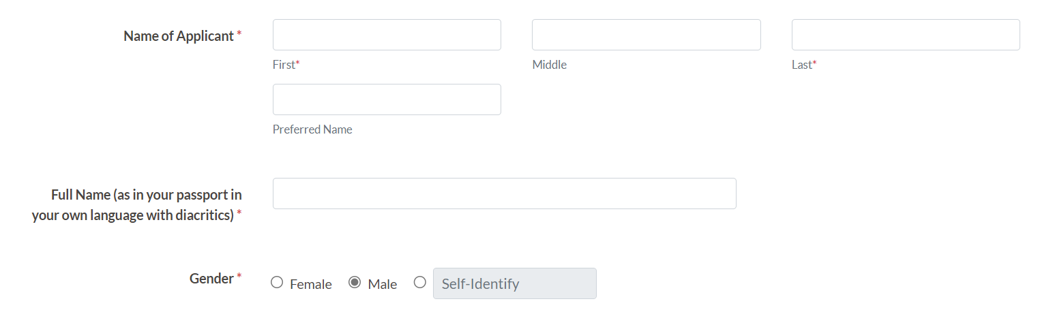
Country Coordinator Comment: Preferred name nije nadimak, nego ime kojim želite da vas oslovljavaju u školi. Ukoliko je isto kao i vase ime, ostavite prazno.
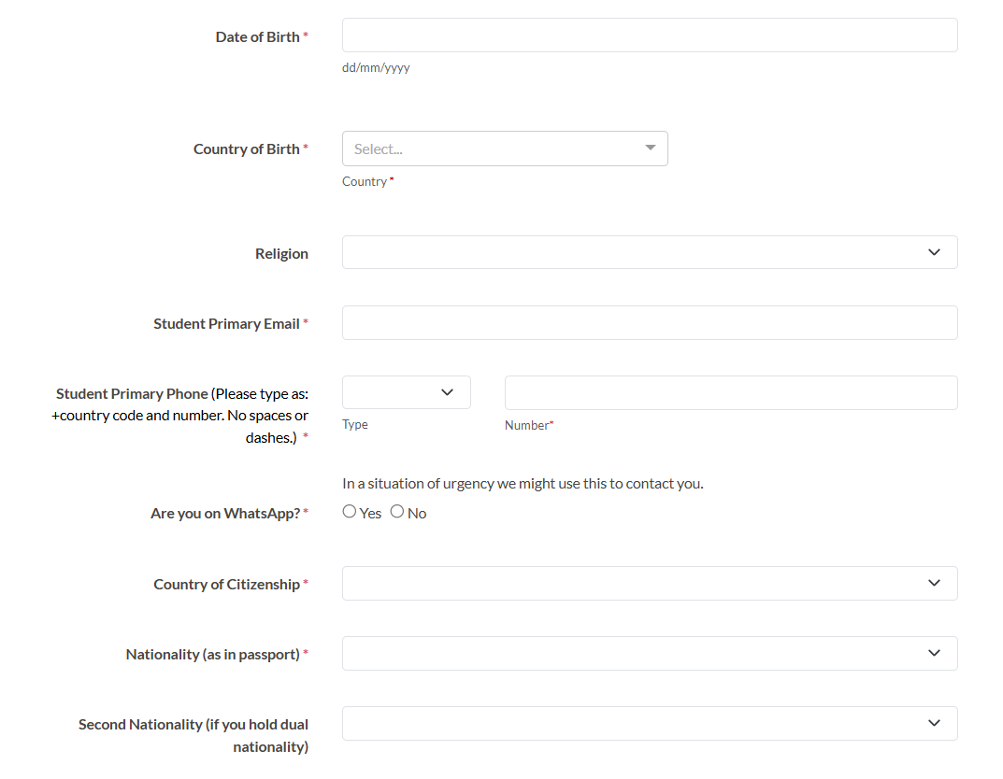
Country Coordinator Comment: Religijsko opredjeljenje kandidata ne utiče na process izbora.
Section 3: Educational Information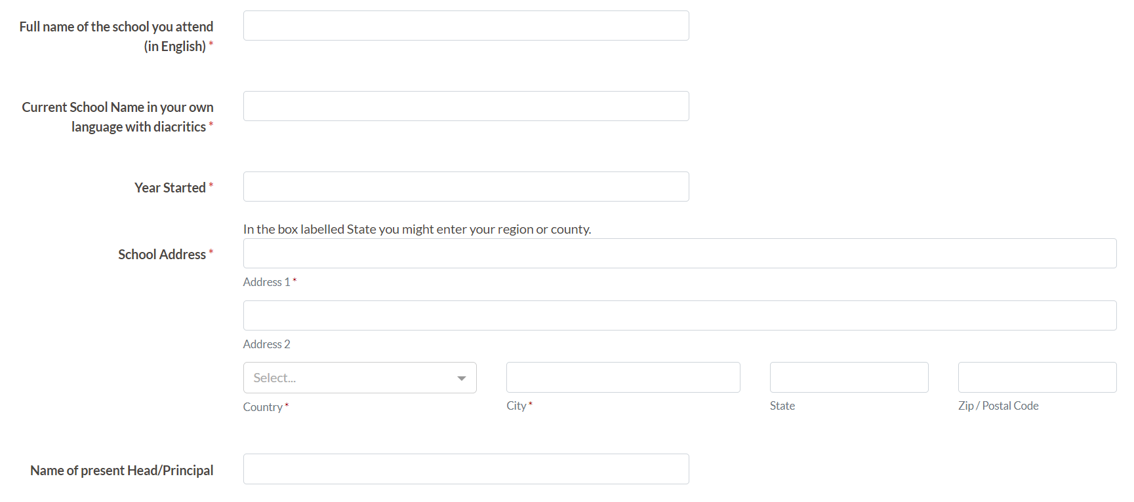
Country Coordinator Comments: U kontekstu Bosne i Hercegovine, za State možete staviti x. Zip code se odnosi na poštanski broj mjesta.
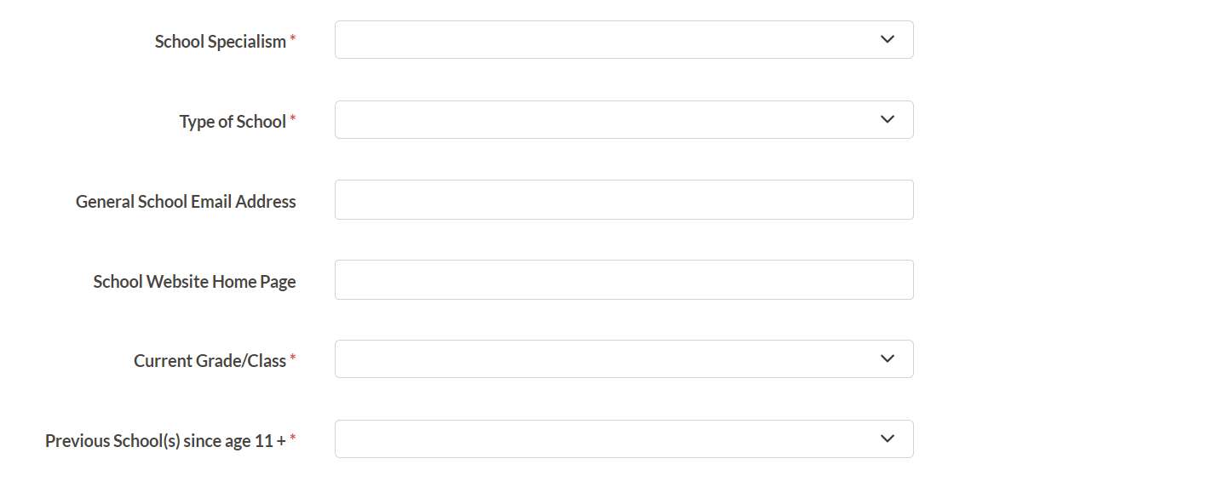
School Specialism will give options of General, Classical, Science, Bilingual, Online, Other. Type will give options of Public or Private. If attending any other school(s) since age 11 it will ask for the name of the school, type and the year started and finished.
Section 4: Language Skills
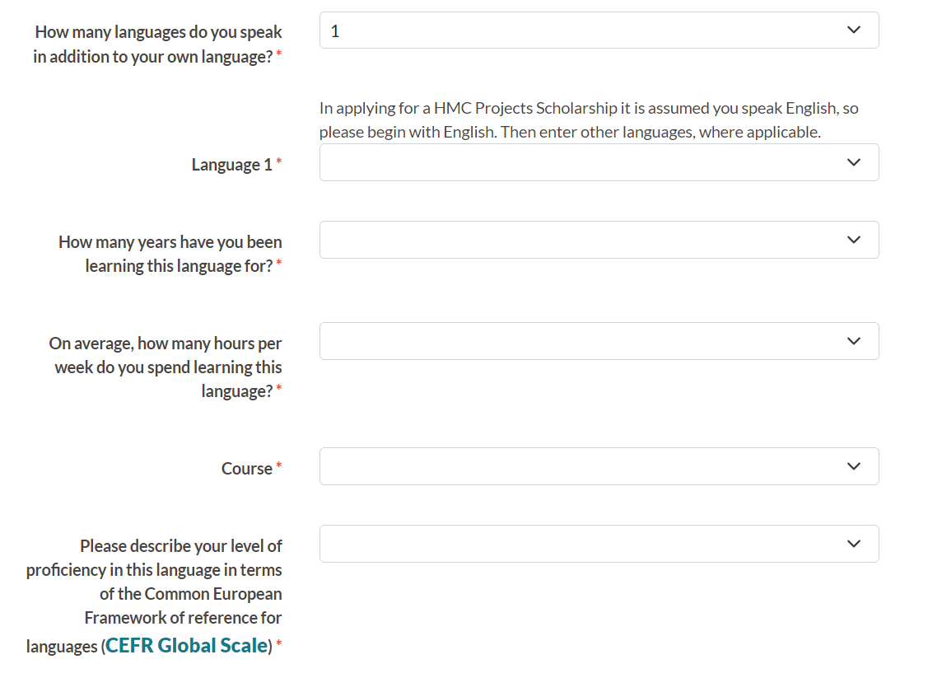
Though illustrated (above) for 1 language, you can enter up to 5 languages additional to your own language. Please start with English. The Common European Framework of Reference for Languages is linked here. You are also asked (see top of next page) whether you have transcript evidence for that level. If so, you upload that later as what is called a checklist item.

Section 5: Academic, Extracurricular and Personal Interests
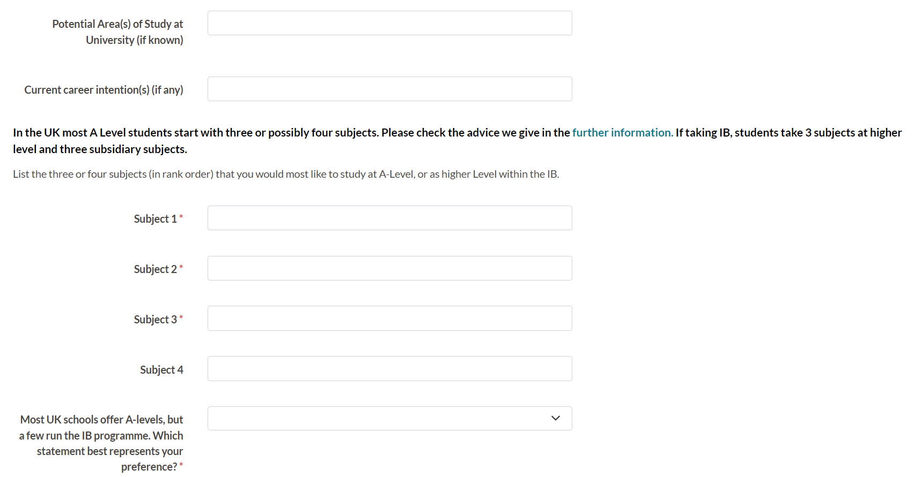
Please read HMC Projects “Choosing subjects to study in the UK education system” when completing the section above. In the section below, note this is academic awards.

You are then asked questions about sporting; performing and visual arts; clubs, organisations, or community service groups. The format is similar for each category and illustrated below for sport below. You can add up to 3 sports; 4 performing and visual arts; 4 clubs, organisations, or community service groups. Think about the priority activities in listing these.

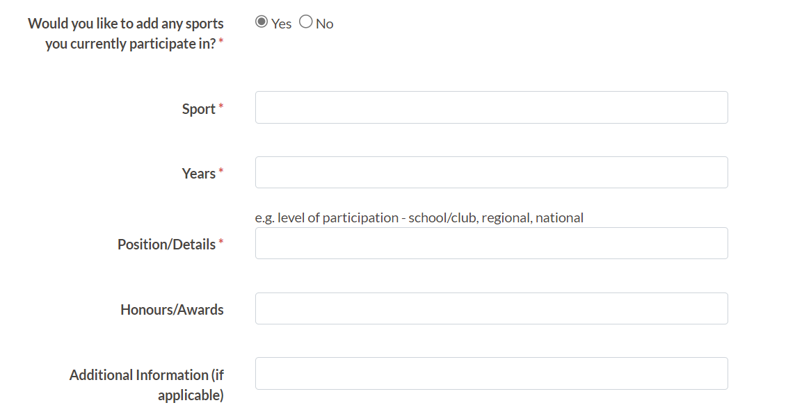
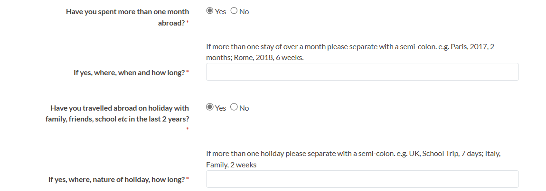
Next (below) you can add up to 4 weblinks to support your application. Consider your priorities.
Note: A later ‘checklist item’ will invite you to upload family photos.
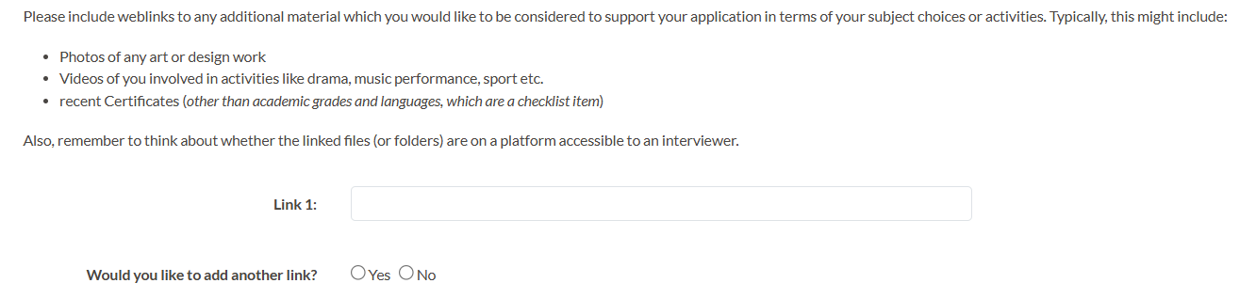
Section 6: Personal Essay
Country Coordinator advice: Pažljivo planirajte esej. U njemu navedite sve ono što mislite da bi moglo pomoći HMC-u da nađe za vas odgovarajuću školu. Što ste precizniji i iskreniji, veća je vjerovatnoća da ćete dobiti školu u kojoj ćete biti sretni.
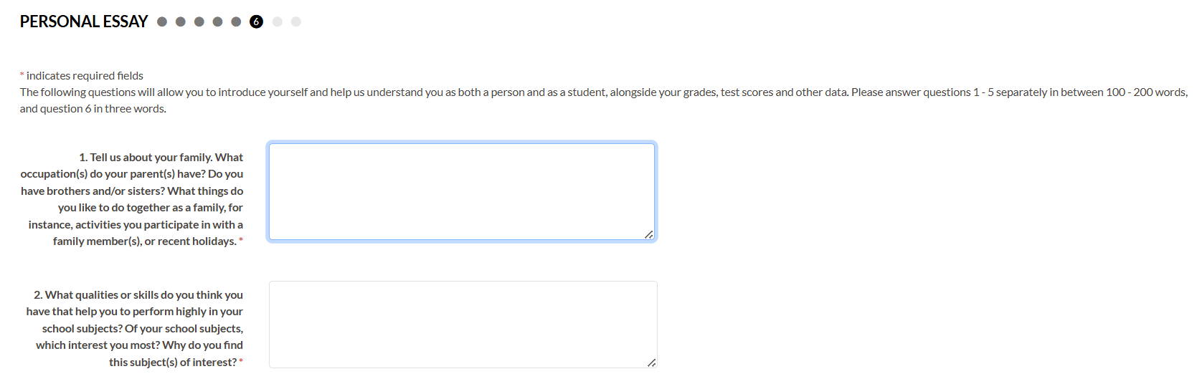
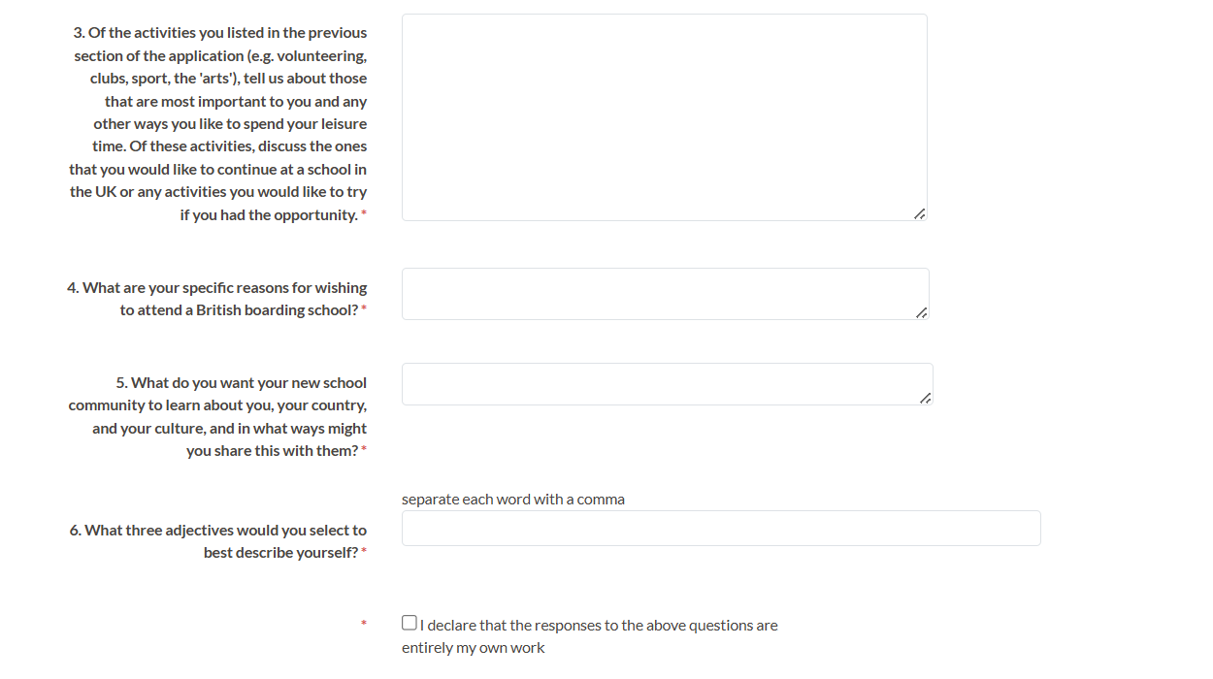
Section 7: Household Information
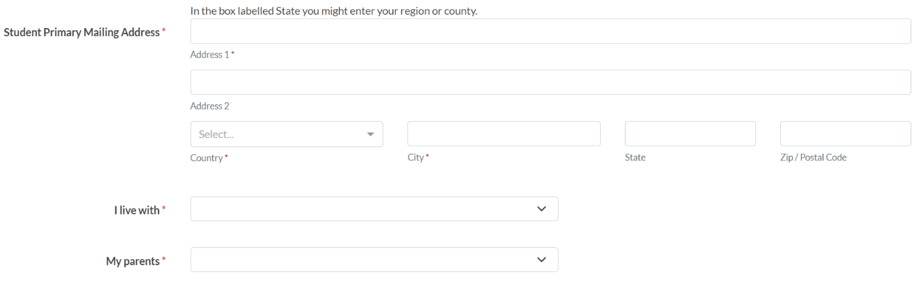
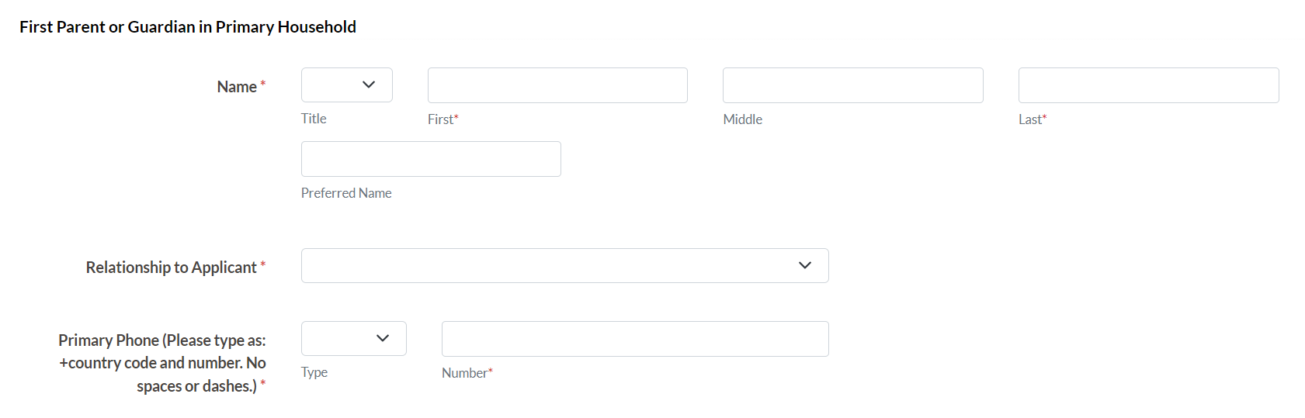
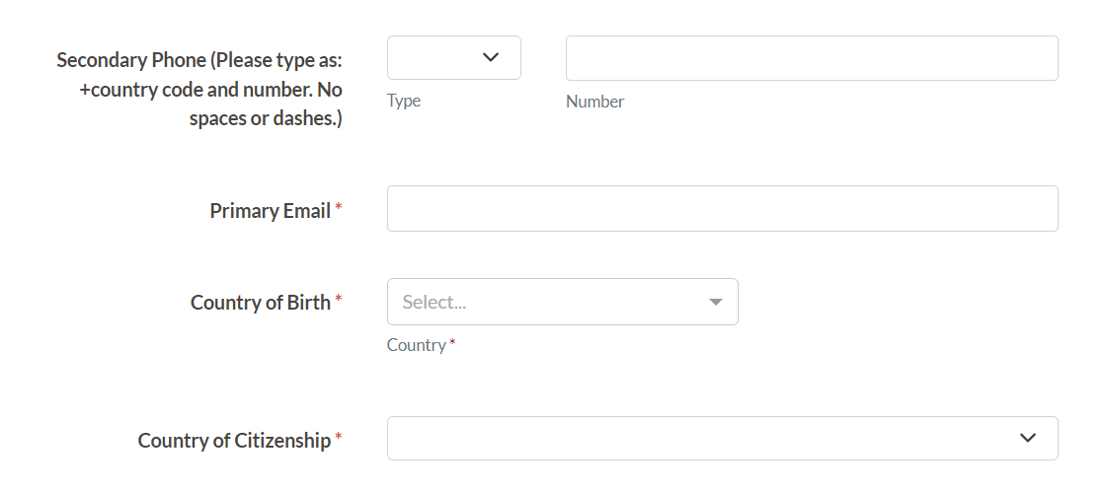
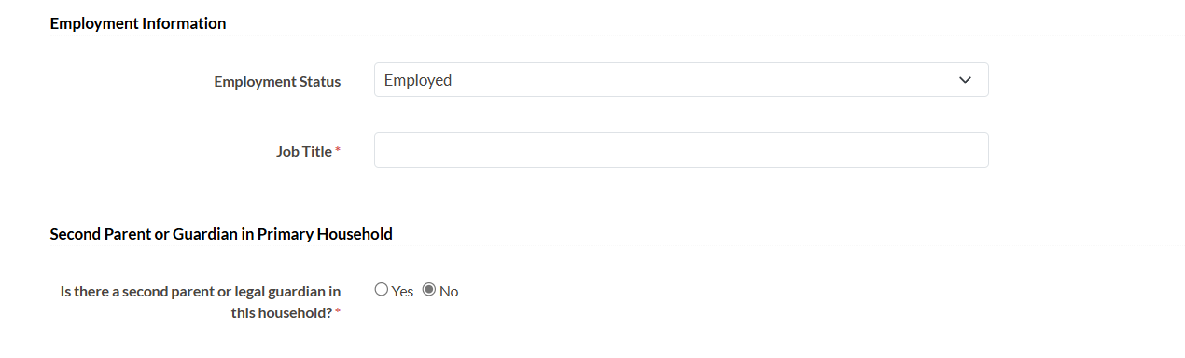
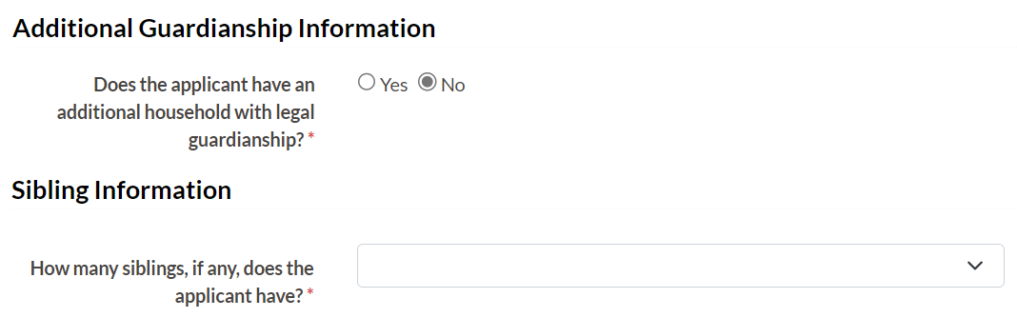
Note: Job Title will only be asked where the response is Employed or Self-Employed. If answering ‘Yes’ to second parent or legal guardian, it will repeat the previous questions. The same is true if there is an additional household with legal guardianship (see below).
For siblings it will request their name, relationship to you, age, current year in school (if that applies) and whether they have been scholars with HMC Projects.

Section 8: Candidate Declaration
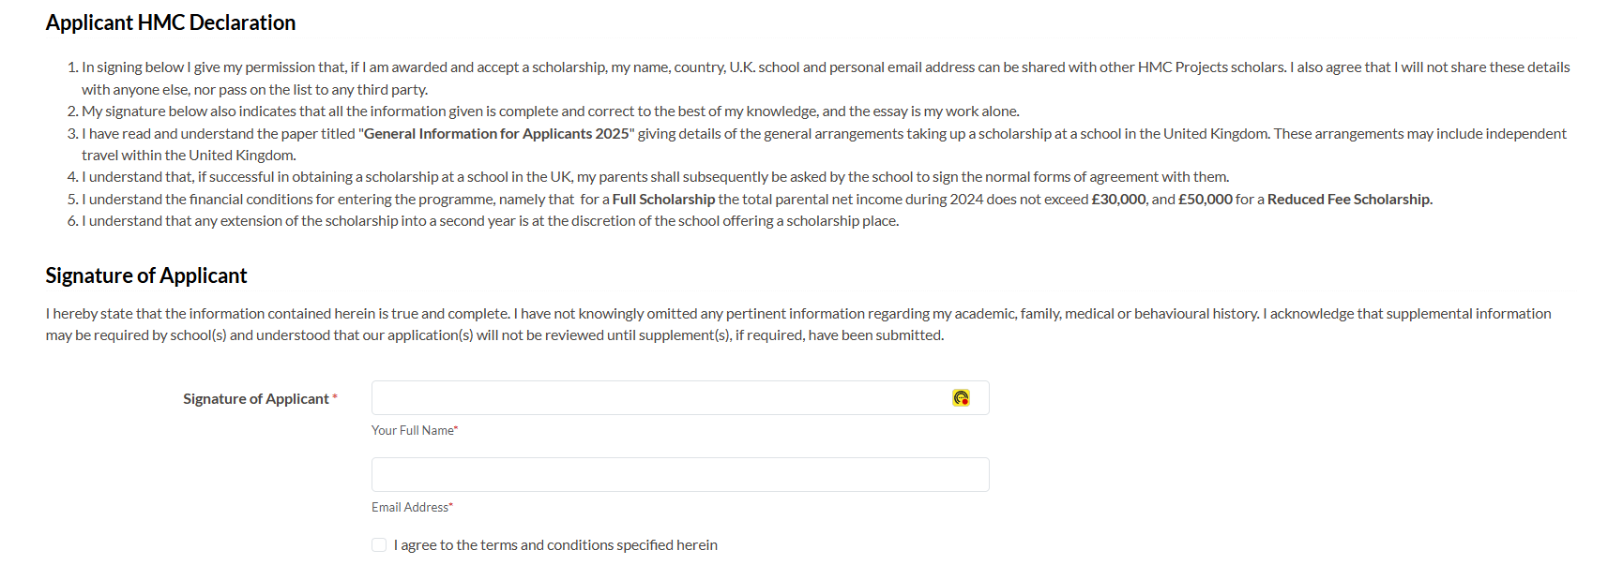
9. Review Screen

Please read the whole application with care and amend if you need to. If you Submit (bottom of this Review page) you cannot make further changes.

After you submit your application, you will receive 2 confirmations:
- The first is a visual confirmation that will appear on the screen after you submit your application.
- The second is a later email thanking you for your application and asking you to visit your portal to view your candidate checklist items e.g. uploading your photos, school grades etc.
Checklist Items
After you have submitted your application form, you will be invited to return to the portal to submit what are called Checklist Items. These are:
- Applicant Photo
- Form Tutor (or School Principal), Maths and English Teacher Recommendations
- Grades
- Additional Supporting Evidence
- Parental Statement & Health Form
- HMC Projects Financial Declaration Form
You will also see listed the Spontaneous Essay Transcript Upload – this will be completed on your behalf by the Country Coordinator.
Applicant Photo – a passport style photo
Teacher Recommendation Forms –Please use the online application system to contact the teacher. Completing the boxes will trigger an email from HMC Projects requesting they complete a form on your behalf. They submit this electronically. You will see when it is complete, but not the content of the recommendation.
Grades – you will be asked to download and complete a form with your grades on. In addition, please upload copies of the actual grade sheets from your school that match the information you entered on our document and uploaded.
Also, please use this section to upload any language certificates (e.g. IELTS) you referred to in the application form
Additional Supporting Evidence – include with your application recent digital photos of you, either by yourself or with your family or small group of friends at school, locally or on holiday. You might want this to reflect activities that matter to you, and you have mentioned in your application. Maximum number of 4 photos.
Personal Statement & Health Form – your parent(s) should complete this checklist item with you.
HMC Projects Financial Declaration Form - Please ask your parent(s) to complete the online form. This form will be available once you complete the application form, but does not need to be completed unless you are called to interview, in which case it should be completed and submitted as soon as you have been invited to interview.
If you called to interview your parents will also be required to complete an Applicant Signature Form. This item will only appear after you are invited to interview.

